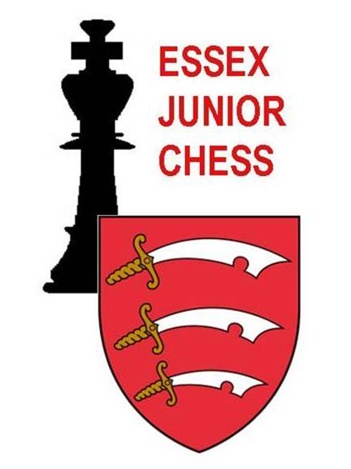

TOURNAMENT PROTOCOL

- Essex Junior Chess Association expects that all parties involved in its tournaments – players, parents and officials – will conduct themselves in an appropriate manner.

- The draw for each round will be made by use of either the Tournament Director or UTU Swiss tournament control programmes. No representations regarding pairings or colours will be entertained.

- If the scoring of the previous round is found to be in error this should be brought to the organiser’s attention as soon as possible. Corrections can only be made between rounds of play and only with the agreement of the Tournament Organiser.

- Parents will not be admitted to the playing hall after the start of each round. Only the Control Team, board stewards, players, and other persons designated by the Tournament Organiser will be allowed in the playing hall.

- In the event of a dispute arising during play, any player who has a complaint may request a ruling or help from a Board Steward. If the player or opponent is unhappy with any decision so made, they may ask for a final ruling by the Tournament Arbiter.

- In the event of a dispute arising during the tournament, the Tournament Arbiter shall have the final decision. There is no appeal against the decision of the Tournament Arbiter.

- It is expected that players who win prizes will remain for the prize giving. Players who are unable to collect their prize by reason of absence from the prize giving (without prior notice of such to the Tournament Organiser) will forfeit the prize.

EJCA
October 2016

