The Southend-on-Sea Junior Chess Tournament

Sunday 9th February 2020
Register before 9.30am

Prince Avenue Academy,
Hornby Avenue,
Westcliff-on-Sea,
SS0 0LG

Travel to the venue
The venue is a 20 minute walk from Southend Airport Station.
Trains from London Liverpool Street run every 30 minutes.

Illegal moves:
The Under 9 and 11 sections will be played to EPSCA Quickplay rules (Rule 11). An illegal move suffers the normal penalties of the touch-move rule. Such a move is completed once the opponent’s clock has been started. If either player has less than five minutes left on the clock and an illegal move is made, the Arbiter will award the opponent two minutes for the first offence, and two minutes for a second offence. A further offence will lead to the loss of the game.
In the Under 18 sections, FIDE rule 7.5b and A4b will not be enforced. Players will be allowed 2 illegal moves at any time in the game with 1 minute awarded to their opponent, the third leading to the loss of the game.

Any questions concerning the event may be directed to Dave Hawkins
on 020 8531 5066 or davehawkins126@googlemail.com

Telephone number FOR THE DAY ONLY is 07853 138048
Visit our NEW website www.essexjuniorchess.co.uk
and facebook page
https://www.facebook.com/Essex-Junior-Chess-Association-315756195974956/

The Southend-on-Sea Junior
Chess Tournament

Essex Junior Grand Prix: Round 3

Sunday 9th February 2020

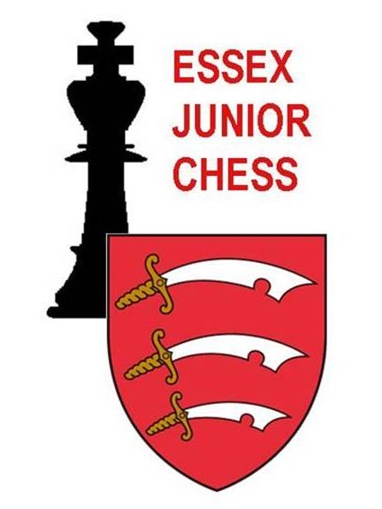

An Essex Open event:-
Under 9, Under 11 and Under 18 sections.

organised by Essex Junior Chess Association
at

Prince Avenue Academy,
Hornby Avenue,
Westcliff-on-Sea
SS0 0LG

ENTRY FORM

Surname: ......................................... First name: ........................................

Address: ..........................................................................................................

............................................................................................................................

Post code: ................... Telephone no: ..................................................

Email: .................................................................................

School: ....................................... Chess club: .................................................

ECF rapid grade: .............. (if you have one)

ECF no. if you hold Silver level membership or above? ………………….

Date of birth: ............................. School year group: ...............

Section entered U9 U11 U18 minor (ECF Rapid Grade 110 or less) U18 Open
(age at 31st Aug 2019)
Boy or Girl

Enter by:

Emailing form completed in WORD (no photos please) to
essexjuniorchess@gmail.com
and transferring entry fee to 30-96-94 a/c 27494268. Reference in the format GP3-20 J.Smith (player’s name, not parent’s)

Receipt of your entry will be confirmed by email

The organisers reserve the right to refuse entry without explanation.

Your details will be held on computer for the sole purpose of informing you of future Junior chess events. Unless permission is specifically withheld, photographs taken during the day may be used on the EJCA website.

The event will be paired as a Swiss Tournament of 6 rounds – it is not a knock-out. All players will be expected to play in all 6 rounds.

All games will be played using chess clocks. U9 & U11 sections - all moves to be made in 30 minutes. U18 sections – 25 minutes + 5 seconds per move.
All results will be submitted to ECF for grading.

Registration is from 9.00 until 9.30am.
Round One begins at 9.45 am.
Prize giving will be as soon as possible after 5.15 pm.
Default time will be 10 minutes after the actual start time.

There will be trophies for the top 3 players in each of the U9 and U11 sections. All players in these sections will receive a certificate. There will be cash prizes offered in the U18 sections; the prize fund will be £60 in the Minor and £120 in the Open. First prize will be 50% of the fund. There will be a supplementary prize fund of £50, to be awarded at the tournament organiser’s discretion.
The U18 minor is open to any player with an ECF Rapid Grade of 110 or below. If there are insufficient entries in any section, the organisers reserve the right to combine sections. Grand Prix multipliers will be adjusted accordingly

Entry fee for all sections is £13.00 for English Chess Federation Silver or Gold members, £16.00 for non-members. Deduct £3 from total if 2 siblings entering; £4.50 for 3. Late entries received after the closing date of Wednesday 5th February will be accepted only if space permits, and with an additional fee of £2.50.

The attention of entrants and parents is drawn to the ‘Tournament Protocol’ on the EJCA website.

The organisers will not be able to accept responsibility for the supervision of players between rounds.

Drinks and light refreshments will be on sale during the day.

