The Chelmsford Autumn Junior Chess Tournament

Saturday 4th October 2025
Register before 9.30am

Moulsham Junior School
Princes Road
Chelmsford
CM2 9DG

Illegal moves:
The Under 8, 10 and 12 sections will be played to EPSCA Quickplay rules (Rule 11). An illegal move suffers the normal penalties of the touch-move rule. Such a move is completed once the opponent’s clock has been started. If either player has less than five minutes left on the clock and an illegal move is made, the Arbiter will award the opponent two minutes for the first offence, and two minutes for a second offence. A further offence will lead to the loss of the game.
In the Under 18 sections, FIDE rule 7.5b and A4b will not be enforced. Players will be allowed 2 illegal moves at any time in the game with 1 minute awarded to their opponent, the third leading to the loss of the game.

Any questions concerning the event may be directed to essexjuniorchess@gmail.com

Telephone number for the day only is 07816 145729

Visit us at:

Website https://www.essexjuniorchess.co.uk/
Facebook https://www.facebook.com/essexjuniorchess
Twitter - https://twitter.com/EssexJrChess

The Chelmsford Autumn Junior
Chess Tournament

Round 1 of the EJCA Grand Prix, and an LJCC qualifying event

Saturday 4th October 2025

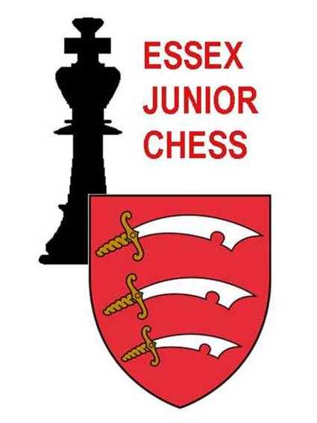

An Essex Open event for Under 8s,
Under 10s, Under 12s and Under 18s
organised by Essex Junior Chess Association
at

Moulsham Junior School
Princes Road
Chelmsford
CM2 9DG

HOW TO ENTER:

Please use the following link and complete the google form:

Chelmsford 4th October 2025 - Google Forms

Any queries should be addressed to essexjuniorchess@gmail.com

PAYMENT:

At time of entry, transfer entry fee to EJCA 30-96-94 a/c 27494268. Use player’s name as reference.
If payment is not received by the closing date, this will incur an additional fee of £5.00

Receipt of your entry will be confirmed by email. The organisers reserve the right to refuse entry without explanation.

Drinks and light refreshments will be on sale during the day, provided by Angelin Chatti, which will be payable with cash only.
The organisers will not be able to accept responsibility for the supervision of players between rounds.

The attention of entrants and parents is drawn to the ‘Tournament Protocol’ on the EJCA website.

The organisers take no responsibility for looking after the children. This is down to the accompanying adult. All children in Year 6 or below need to be accompanied by an adult for the duration of the tournament.

Older children can be left if it is arranged in advance and full contact and medical details are given. The organisers will not be responsible for any child and cannot act in loco parentis and any child left unaccompanied is at the parents’ risk. There will be gaps between games.

The organisers also cannot take responsibility for any theft or accident during the event.

Photos of the children may be taken by the organisers in the playing hall. These may be published on chess websites or in chess related articles. If you do not wish your child to be photographed, you must inform the organisers by email before the start of the event.

Your email address may be used to send chess related information if you do not inform us otherwise.

The event will be paired as a Swiss Tournament of 6 rounds – it is not a knock-out. All players will be expected to play in all 6 rounds.

All games will be played using chess clocks. Time control for all sections will be 25 minutes + 5 seconds per move.
All results will be submitted to ECF for rating.

Registration is from 9.00 until 9.30am.
Round One begins at 9.45 am.
Prize giving will be as soon as possible after 5.20 pm.
Default time will be 10 minutes after the actual start time.

There will be trophies for the top 3 players in each of the U8, U10 & U12 sections. All players in these sections will receive a certificate. There will be cash prizes offered in the U18 sections, including grading prizes for those players with lower or no ratings; the prize fund will be £60 in the Minor and £120 in the Open. First prize will be 50% of the fund in each case. There will be a supplementary prize fund of £50, to be awarded at the tournament organiser’s discretion. Prize winners are expected to attend the prize giving. The U18 minor is open to any player with an ECF rapid rating of 1300 or below. If there are insufficient entries in any section, the organisers reserve the right to combine sections.

The Arbiter’s decision will be final in all chess-related matters.

Entry fee for all sections is £20.00 for English Chess Federation members, £23.00 for non-members. Late entries received after the closing date of Wednesday 1st October 2025 will be accepted only if space permits, and with an additional fee of £.5.00 No entries will be accepted on the day.

